South Sudan

## Political Stability Estimate Data

The data set shows the political stability estimate of the country each year.

## # A tibble: 19 x 5  
## country iso3c date stability stabilityCategory4  
## <chr> <chr> <dbl> <dbl> <chr>   
## 1 South Sudan SSD 1996 0.990 moderately stable   
## 2 South Sudan SSD 1998 0.990 moderately stable   
## 3 South Sudan SSD 2000 0.990 moderately stable   
## 4 South Sudan SSD 2002 0.990 moderately stable   
## 5 South Sudan SSD 2003 0.990 moderately stable   
## 6 South Sudan SSD 2004 0.990 moderately stable   
## 7 South Sudan SSD 2005 0.990 moderately stable   
## 8 South Sudan SSD 2006 0.990 moderately stable   
## 9 South Sudan SSD 2007 0.990 moderately stable   
## 10 South Sudan SSD 2008 0.990 moderately stable   
## 11 South Sudan SSD 2009 0.990 moderately stable   
## 12 South Sudan SSD 2010 0.990 moderately stable   
## 13 South Sudan SSD 2011 -1.43 highly unstable   
## 14 South Sudan SSD 2012 -1.16 highly unstable   
## 15 South Sudan SSD 2013 -1.73 highly unstable   
## 16 South Sudan SSD 2014 -2.65 highly unstable   
## 17 South Sudan SSD 2015 -2.38 highly unstable   
## 18 South Sudan SSD 2016 -2.42 highly unstable   
## 19 South Sudan SSD 2017 -2.46 highly unstable

## Political Stability Estimate Plot

The plot shows the trends of stabilization and destabilization for the each country.

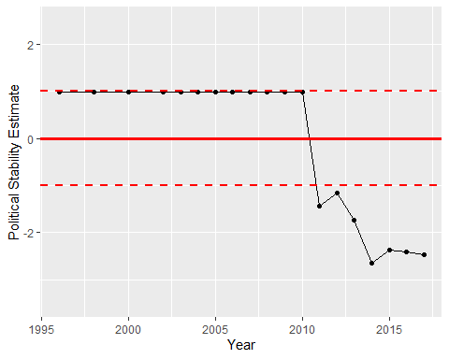

Political Stability Trend